Cartoonist Callout for
The 11th Annual
Cartoon Days of Christmas (TCDC)
cartoons are due in by November 20th, 2012!
Cartoonists interested in some free promotional fun are invited to participate in the 11th Annual On-line The Cartoon Days of Christmas (TCDC). This year’s TCDC will begin on December 1st and run through January 5th at www.the-cartoonist.com. Cartoons need to be submitted by November 20th in order to be posted on the web site.

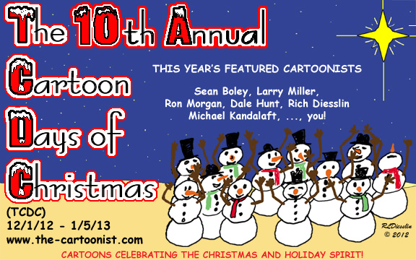

Each cartoonist will have their cartoons (two or more) featured on the theme of humor in the Christmas season. It will be G-rated fun for the whole family and help to keep the hustle and bustle of the holidays in perspective. More details can be found at www.the-cartoonist.com! Hope you will consider joining the fun. The more the merrier!

The Cartoon Days of Christmas (TCDC) will be hosted at Rich Diesslin’s http://www.the-cartoonist.com. Rich is known for his freelance cartoons and cartoon books on a variety of topics including his recent e-book KNOTS scouting, Out-to-Lunch general and Gospel cartoons. This foray into Christmas humor is one of the ways the cartoonists can draw attention to their cartoons, blogs and web sites! It’s free publicity for those participating, and this year they will again be able to have two cartoons added to the gift shop to generate a little bit of revenue next year!

To summarize what you need to participate …

- RSVP e-mail to Rich so you can be kept up-to-date on any developments
- Basic stuff needed for your web page:

- 2 or more cartoons on Christmas (G or PG-rated)
- a brief biography (one or two paragraphs)
- a banner and/or contact information

- E-mail them to Rich by November 20th
- Promote the event to your contacts
- Enjoy the show!

Content will be screened for suitability on a family-oriented web site! Further information is available upon request, including interviews and graphics as needed.

Contact Information: Rich Diesslin at rich@the-cartoonist.com. Thanks!

