PRESS RELEASE:
The 8th Annual
Cartoon Days of Christmas (TCDC)
December 1st, 2010 – January 5th, 2011
at www.the-cartoonist.com
Some cartoonists from in and about North America will participate in the 8th Annual On-line The Cartoon Days of Christmas (TCDC). This year’s TCDC will begin on December 1st and run through January 5th at www.the-cartoonist.com.

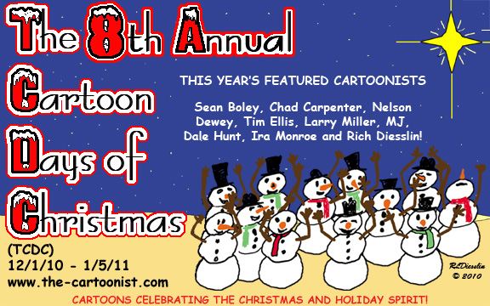

Each cartoonist will have a page featuring cartoons on the theme of humor in the Christmas season. It will be G-rated fun for the whole family and help to keep the hustle and bustle of the holidays in perspective. This year’s cartoonists, in alphabetical order, are Sean Boley, Chad Carpenter, Nelson Dewey, Rich Diesslin, Dale Hunt, Larry Miller, Ira Monroe, and Tim Ellis and possibly some others! They hale from all around the US and Canada.

The Cartoon Days of Christmas (TCDC) will be hosted at Rich Diesslin’s web site at
http://www.the-cartoonist.com. Rich is known for his freelance cartoons and cartoon books on a variety of topics including his Out-to-Lunch general cartoons, KNOTS or Not Scouting Cartoons and The Cartoon Gospel Series. This foray into Christmas humor is one of the ways Rich and his cartoonist friends draw attention to their cartoons!

Here is a sneak peek at one of Rich’s cartoons for this year …

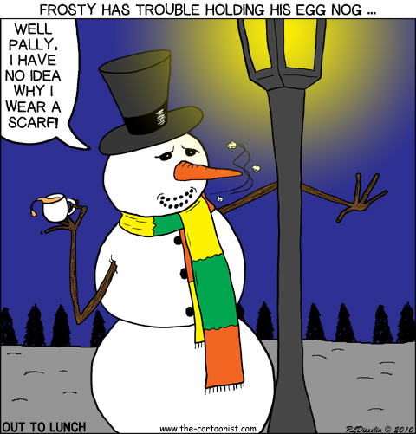

So while you are surfing the web catch a lot of laughs at TCDC - brought to you by a bunch of crazy cartoonists!

Further information is available upon request, including interviews and graphics as needed. Contact Information: Rich Diesslin, 937-429-0139, rich@the-cartoonist.com. Thanks!



