PRESS RELEASE:
The 11th Annual
Cartoon Days of Christmas (TCDC)
December 1st, 2013 – January 5th, 2014
at www.The-Cartoonist.Com
Some cartoonists from in and about North America will participate in the 11th Annual On-line The Cartoon Days of Christmas (TCDC). This year’s TCDC will begin on December 1st and run through January 5th at www.the-cartoonist.com.

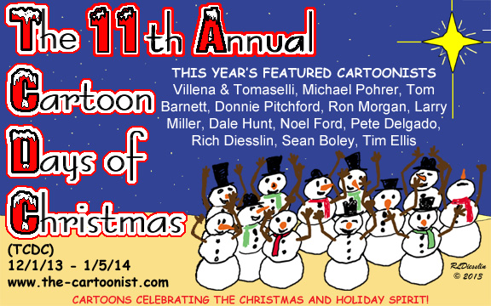

Each cartoonist will feature some of their cartoons on the theme of humor in the Christmas season. It will be G-rated fun for the whole family and help to keep the hustle and bustle of the holidays in perspective. This year’s featured cartoonists are Michael Pohrer, Tom Barnett, Donnie Pitchford, Ron Morgan, Larry Miller, Dale Hunt, Noel Ford, Pete Delgado, Rich Diesslin, Sean Boley, Tim Ellis, Jose Villena and David Tomaselli. And possibly some late arrivals! There are over 300 Christmas cartoons to see spanning all 11 years!

So while you are surfing the web come and catch a lot of laughs at TCDC - brought to you by a bunch of crazy cartoonists! Further information is available upon request, including interviews and graphics as needed. Contact Information: Rich Diesslin, 937-429-0139, rich@the-cartoonist.com. Thanks!


Alternate TCDC Logo:

