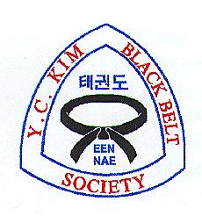
Y.C. Kim Black Belt Society

BLACK BELT AGREEMENT

I AGREE THAT:

1. I will continue to train as hard as before I received my black belt, striving to improve myself mentally and physically.

2. I will help the junior students by teaching them and guiding them by my good example. I will respect and support the senior Black Belts and will be loyal to my instructor.

3. I will not misuse my training and will not behave in any way to degrade the martial arts.

4. I will strive to improve society and to help humanity.

5. If I quit the martial arts training, I will freely relinquish my Black Belt status.

6. If teaching anywhere in the future, I promise to receive permission and teaching recognition from Grand Master Y. C. Kim and the Black Belt Society.

___________________________ _________
Black Belt’s Signature Date

________________________________________
Address

________________________________________
City State ZIP

________________________________________
Phone

